EXPERIMENT 7
1

2

3

4

5

6
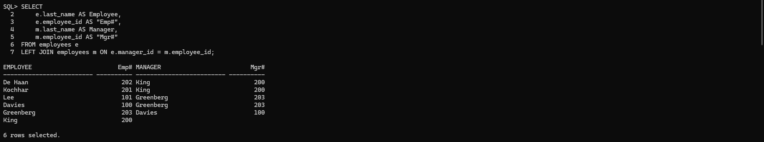
7
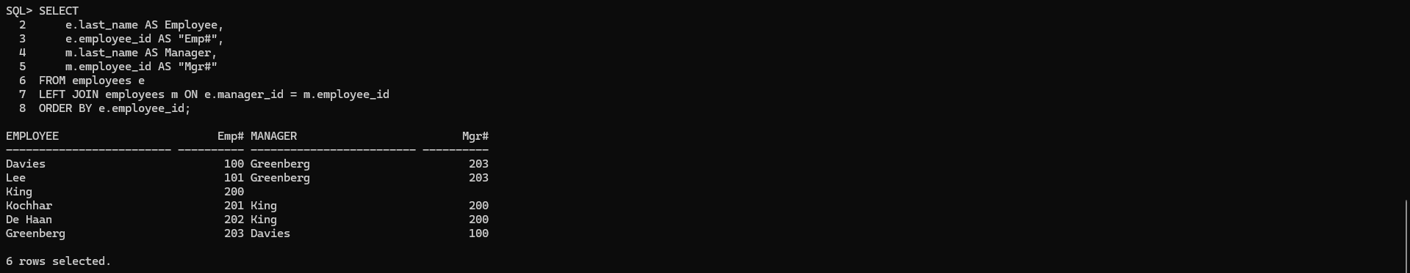
8
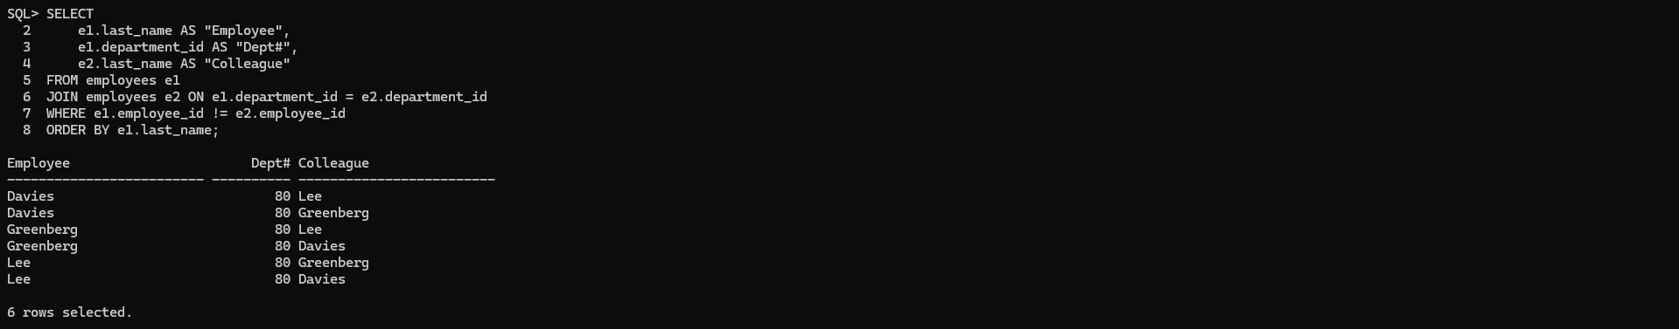
9
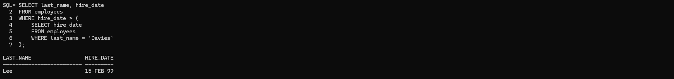
10
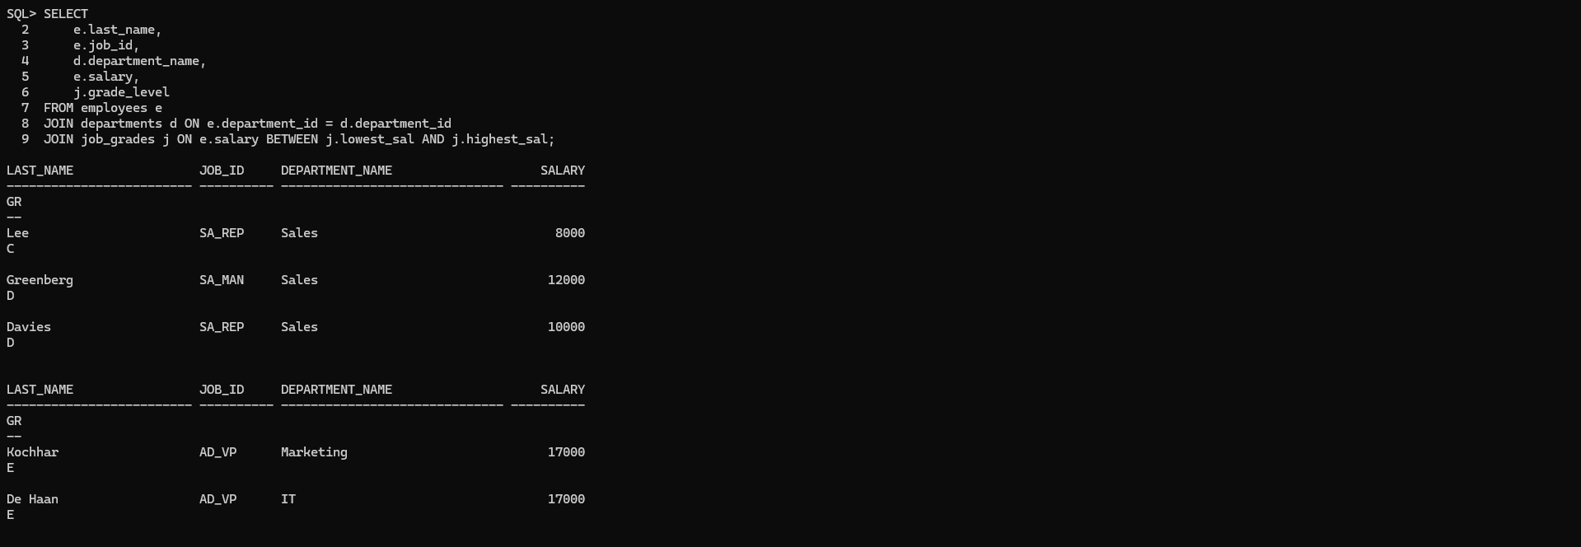
11

